**Renad**

**Description**

**“About Us” page:**

This page includes a summarized description of the idea behind the website.

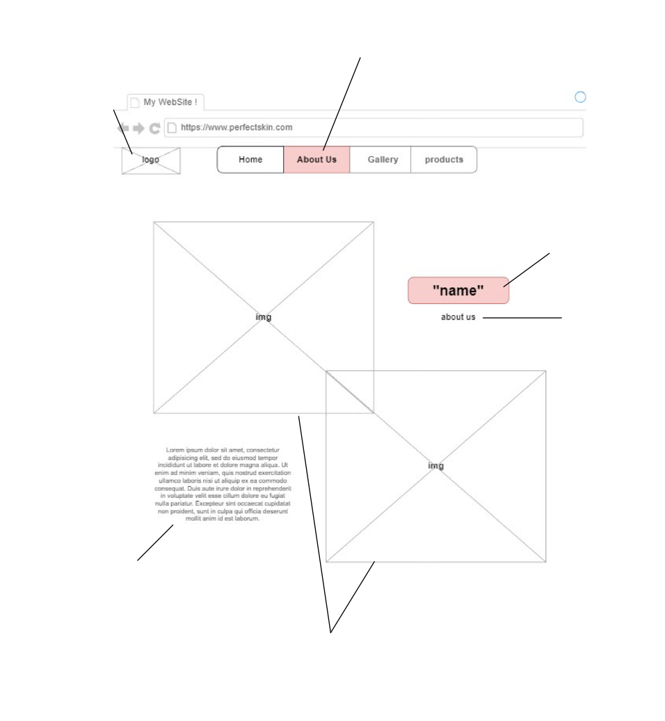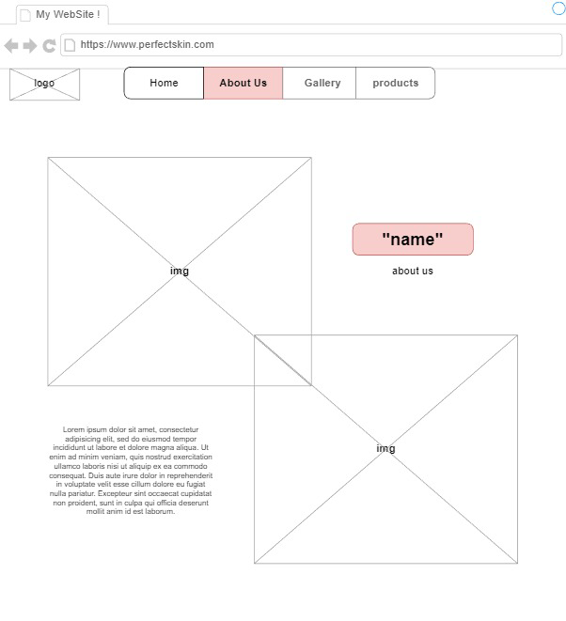

Website’s logo will be inserted here.

A paragraph summarizing what the website is all about for new users visiting the website.

Few images to point out the theme of the website.

The name of the page selected (About Us).



Th name of the website will be here.

The selected page will be shaded in this color to indicate to the user that they are browsing this page.



**Description**

**One of the “Product” pages:**

This page is similar to the other “Product” pages because we wanted the pages of the website to be similar to each other. The user will be transferred to this page when they search for a specific product to view its details.

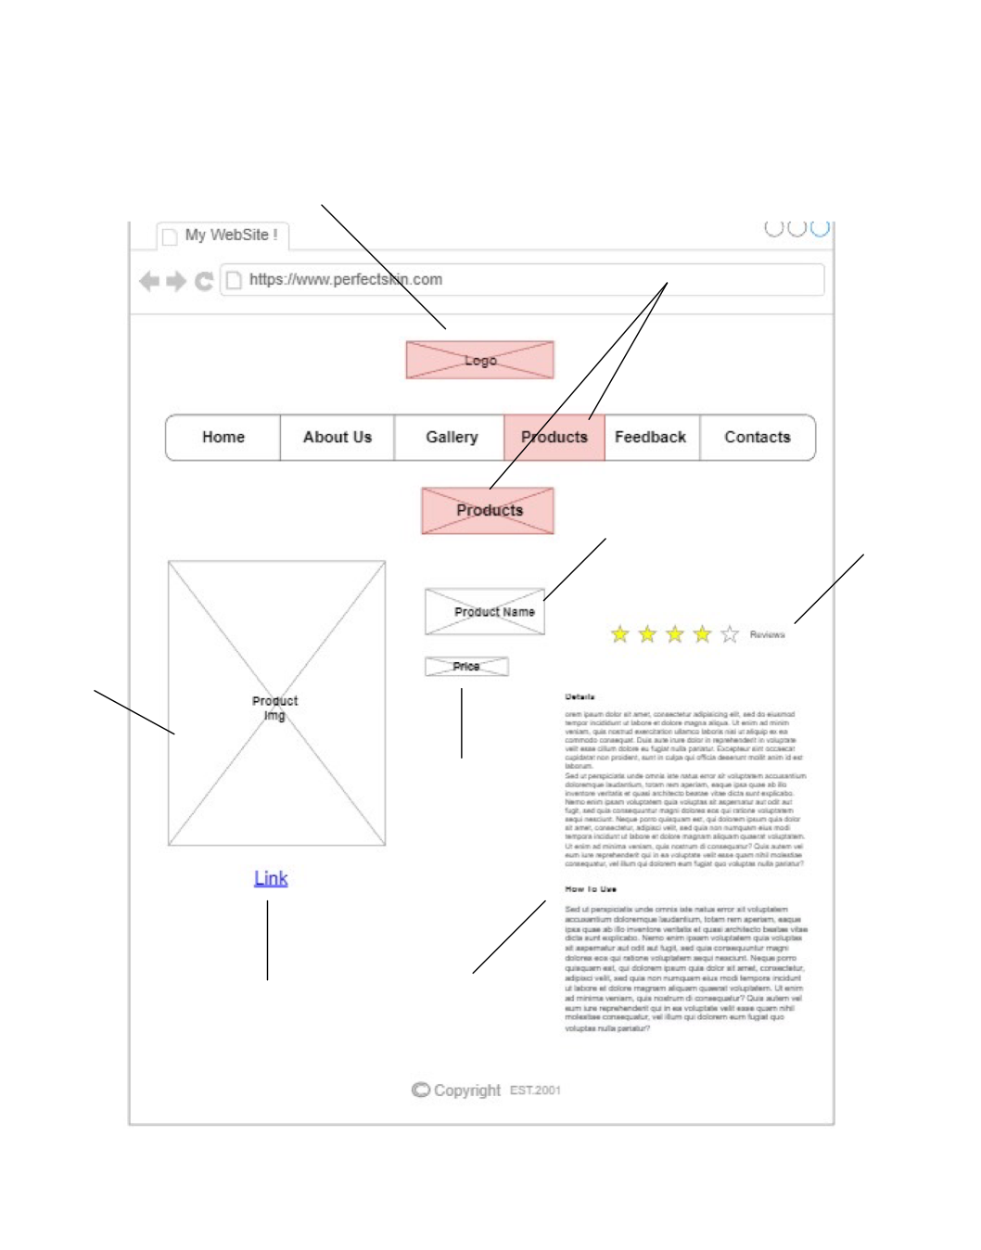

In case the user wanted to purchase the product, they can click on the link to transfer them to the original page of the supplier of the product.

The price of the product.

The name of the product.

The photo of the specified product will be shown here.

Those two paragraphs include all the details about the product. It includes the ingredients, instructions, allergy warnings, and other important details.

The stars show the level of satisfaction that people had with the viewed product. The more stars the product gets, the higher the product is rated.

The shaded boxes point out the intended page that the user clicked on.

The logo of the website will be inserted here.